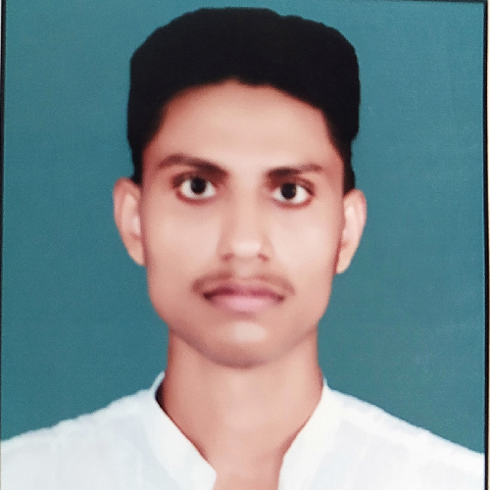

PAWAN YADAV

OBJE CTIVE CONTACT

|  |  |  |
| --- | --- | --- |
| Seeking a challenging position in a reputed |  | 086pawan@gmail.com |
|  | +919580452288 |
| organization where I can learn new skills, expand my |
| knowledge, and leverage my learnings. |  | Panchakosi parikarma marg |

EXP ERIENCE

Near Uadya public school H.no 5/5/16a Shayam

|  |  |  |
| --- | --- | --- |
| IBM  May /2020 - June /2020  Intern  Project : Image Detection  Technologies used : Artificial intelligence using IBM Watson  EDUCATION  Jai Bhawan Institute of Technology 2018-22 | Sadan  SKI LLS | |
|  | C |
|  | C++ |
|  | Python |
|  | HTML |
|  | CSS |
|  | Javascript |

B.Tech CSE

|  |  |  |
| --- | --- | --- |
| RBN Global School  2018  12th  RBN Global School  2016  10th  ACTIVIT IE S | INT ERESTS | |
|  | Learning new things |
|  | Traveling |
|  | Watching movies |
|  | Listening music |
| L A NGUAGE | |
|  | Hindi |
|  | English |



 MACHINE LEARNING AND DATA SCIENCE Location: JN Tech Network (Chandigarh) 1 Day Workshop

 PHP & MySQL Location: CETPA Infotech Pvt. Ltd. (Dehradun) 1 week Workshop

PROJE CTS

Online movie tickets booking system

We have design an online Movie ticket booking system where a user can search a movie in a given city and book it.

DATE O F B IRT H

 29/09/1999

DECL A RAT IO N

 I hereby declare that the above information are true to the best of my knowledge and belief .

Pawan Yadav